## Assignment Description:

As an intern in the Business Analytics team, your task is to analyze a provided dataset and generate actionable insights to optimize page performance for a fictional company called "XYZ Inc." The dataset contains user data from various regions, customer demographics, product information, and marketing campaign details. Your objective is to identify critical factors influencing Data Analysis and Insights for different page Optimization & How to get more user installation & Engagement from the App & Website" User and propose recommendations for improving performance.

app installation for may nearby 5400

# google add campain have the highest user count for may

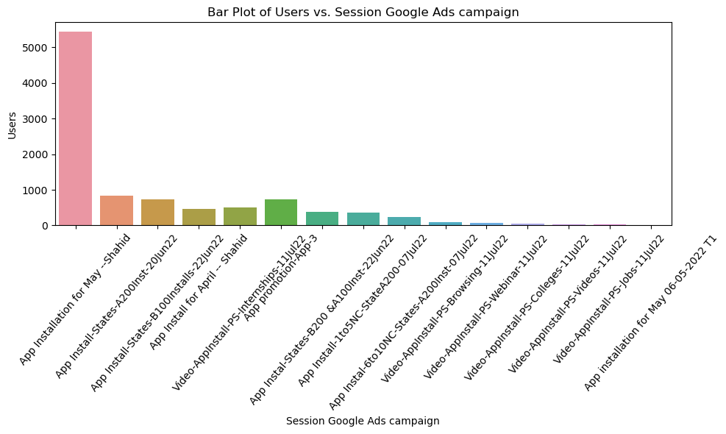

# The total number of sessions generated by the Google Ads campaign users were actively engaged

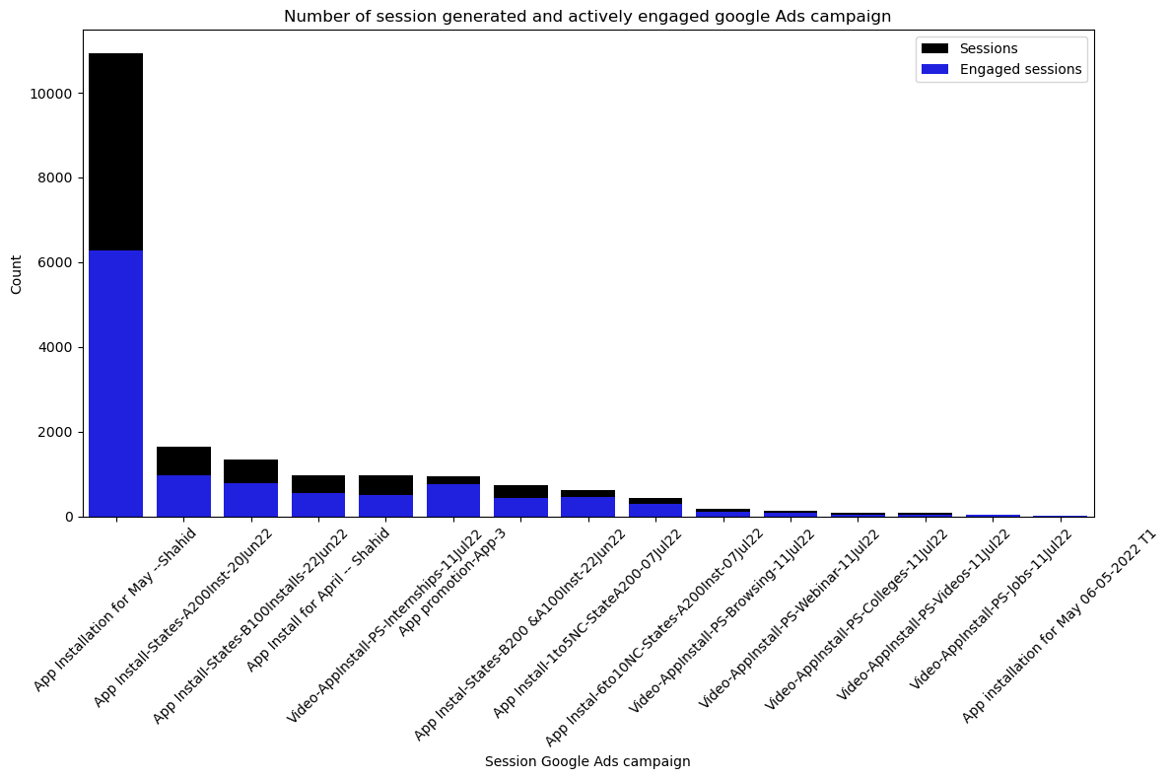

# Cost invested in google ads against return as a event count

cost investment for google adds are is high almost nearby 175000

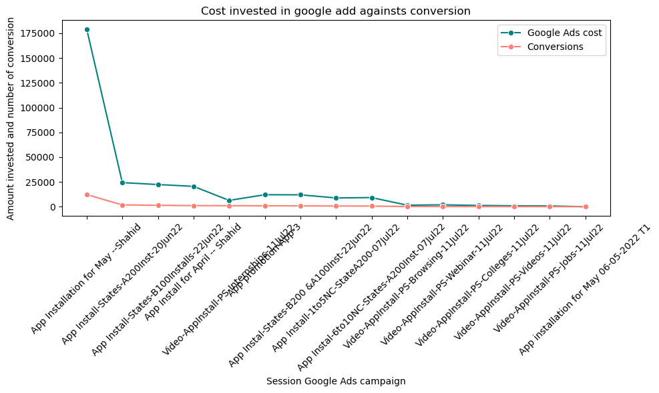

AGE GROP USER

# 18 to 24 age group are high so we should target them,Based on the available data, the "unknown" category appears to have the highest number of users 14000 and new users 13000. To better understand and classify this category, further investigation and data analysis are needed. Apart from the "unknown" category, there is a notable introduction of users and new users from the 18-20 age group.

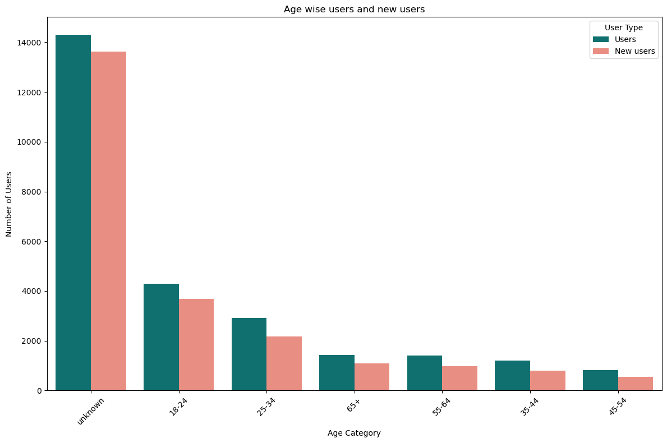

# SEEMAS LOW ENGAGED SESSIONS

UKNOWN ENGAED ARE THERE BUT COUNT IS VERY LESS BUT WE HAVE TO MORE FOCUS ON 18 TO 34 AGE GROUP

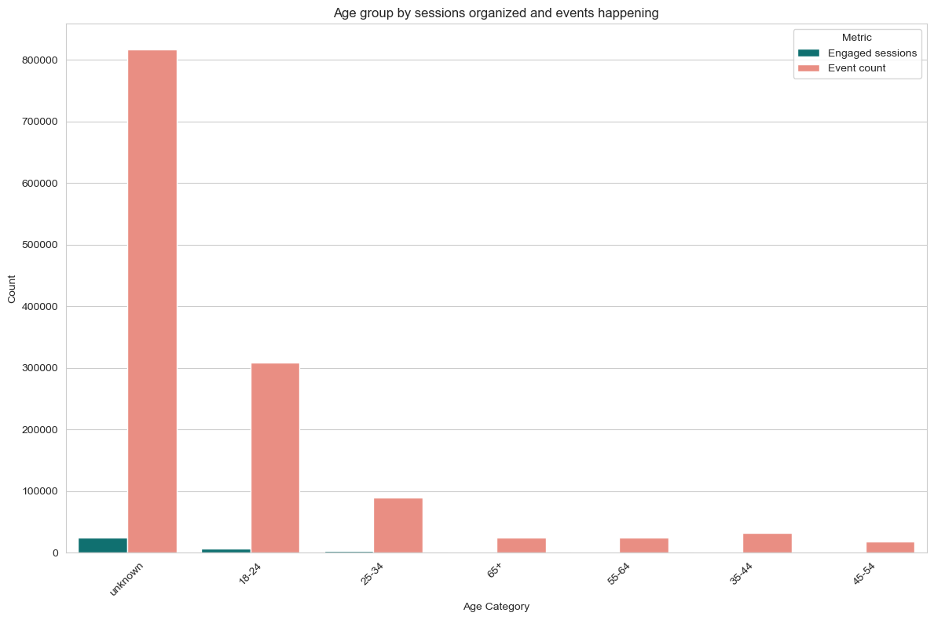

**USER BY LANGUAGE**

| **Language** | **Users** | **New users** | **Engaged sessions** | **Engagement rate** | **Engaged sessions per user** | **Average engagement time** | **Event count** | **Conversions** | **Total revenue** |
| --- | --- | --- | --- | --- | --- | --- | --- | --- | --- |
| **0** | English | 22495 | 21990 | 40639 | 0.595147 | 1.806579 | 341.36350 | 1297970 | 189946 | 0 |
| **1** | Hindi | 586 | 552 | 798 | 0.406314 | 1.361775 | 60.03413 | 13523 | 2699 | 0 |
| **2** | Marathi | 85 | 84 | 98 | 0.426087 | 1.152941 | 38.48235 | 1589 | 323 | 0 |
| **3** | Gujarati | 78 | 77 | 100 | 0.448430 | 1.282051 | 46.53846 | 1794 | 327 | 0 |
| **4** | Telugu | 43 | 42 | 56 | 0.455285 | 1.302326 | 36.65116 | 812 | 170 | 0 |
| **5** | Tamil | 36 | 36 | 43 | 0.518072 | 1.194444 | 45.86111 | 615 | 115 | 0 |
| **6** | Malayalam | 17 | 15 | 36 | 0.654545 | 2.117647 | 161.94120 | 548 | 71 | 0 |
| **7** | Bengali | 14 | 11 | 18 | 0.600000 | 1.285714 | 50.07143 | 217 | 39 | 0 |
| **8** | Chinese | 13 | 13 | 13 | 1.000000 | 1.000000 | 136.76920 | 138 | 20 | 0 |
| **9** | Kannada | 13 | 12 | 31 | 0.500000 | 2.384615 | 249.07690 | 680 | 75 | 0 |
| **10** | Panjabi | 9 | 9 | 17 | 0.708333 | 1.888889 | 92.44444 | 229 | 35 | 0 |

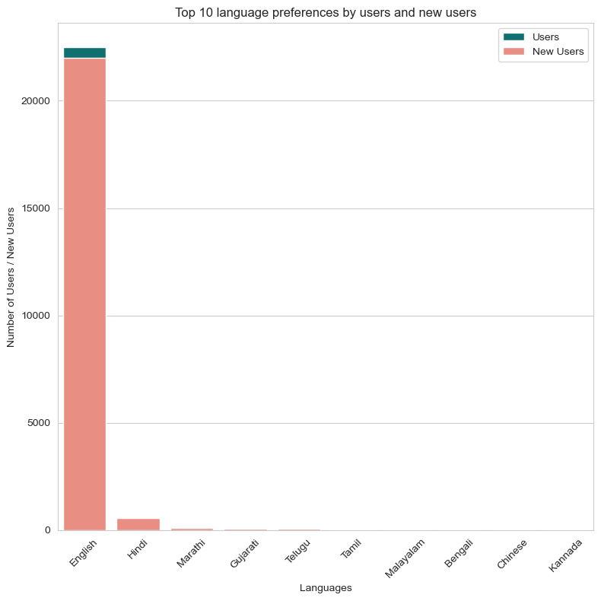

ENGLISH LANGUAGE USERS ARE HIGH SO WE CAN TARGET ENGLISH AS WELL AS HINDI LANGUAGE USER ....

**# User by Interest**

**we need to target more on shoppers,media entertenment,and technology mobile.food and cooking**

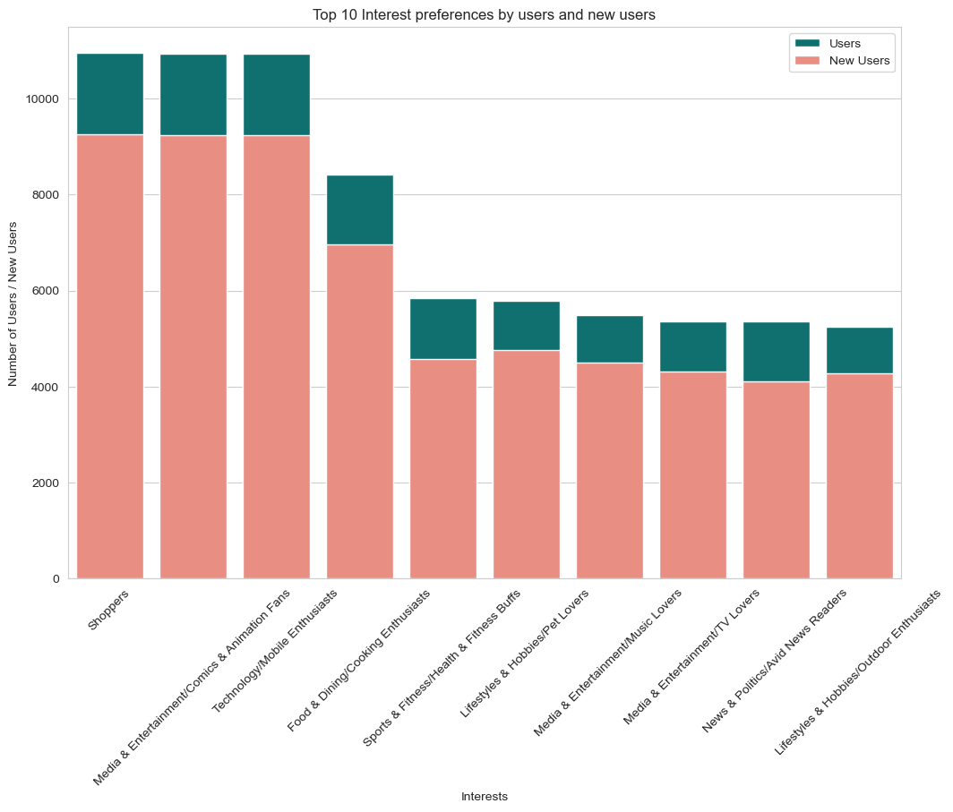

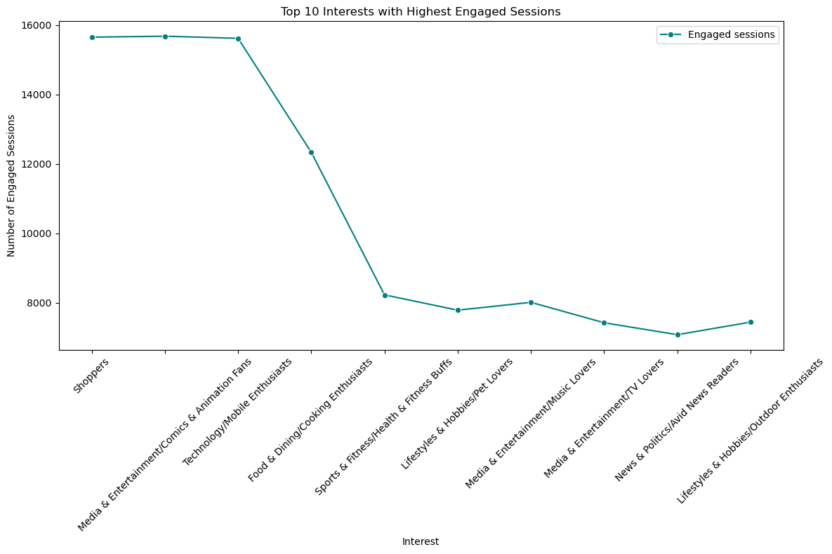

**GENDER REPORT**

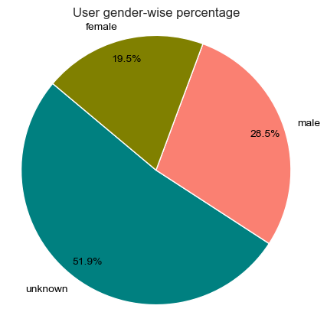

**as you see male gender user high here so we have to target more on male gender and second female**

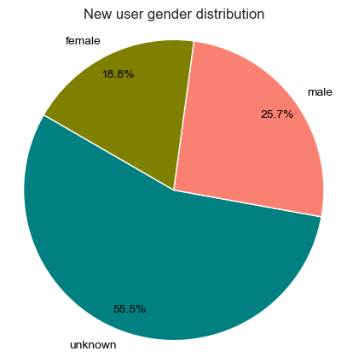

**new user genderwise is male are high so we have to target them more**

**Countrywise new user .**

**as you see we have to focuse more on india it has high user and second we have to target USA.**

